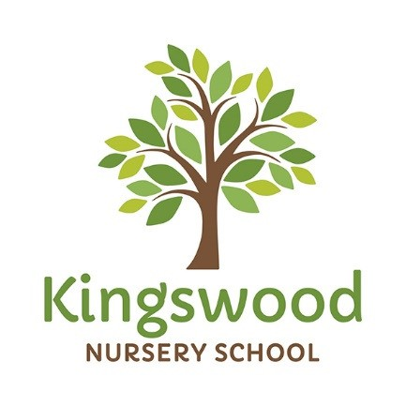
King
s
wood Nursery School

Briar Road
Watford WD25 0DX
Hertfordshire
Nursery: 01923 672531
Pre-School: 01923 679500
www.kingswood.herts.sch.uk
PRE-SCHOOL SESSIONS REQUEST FORM
For two year olds

CHILD’S NAME………………………………………………………………………………………………………..

PROPOSED START DATE………………………………………………………………………………………….

Minimum Of 3 Sessions Per Week | Morning  8.30-11.30 am Inc. snack | Packed Lunch Club  11.30-12.30pm | Afternoon  12.30-3.30pm  Inc. snack | Is your child entitled to 15 hours Free  Funding? *  If so, please tick 5 mornings/afternoons
FEES | £16.50* | £6.00* | £16.50* | Please write your code here: (if applicable)  …………………………………………………
Monday
Tuesday
Wednesday
Thursday
Friday

A whole day 8.30am – 3.30pm - £39.00*
*15 hours Free Funding for three year olds starts the term AFTER their third birthday
Fee Paying Parents only – Please pay your £40 registration fee to secure your place to NatWest Bank
Account Number: 18407757
Sort Code: 60-10-39
* Prices Applicable from 1st January 2021

PLEASE INDICATE WHICH SESSIONS YOU ARE INTERESTED IN BY TICKING THE BOXES

Parent/Carer’s Signature…………………………………………….Date……………………………………………

